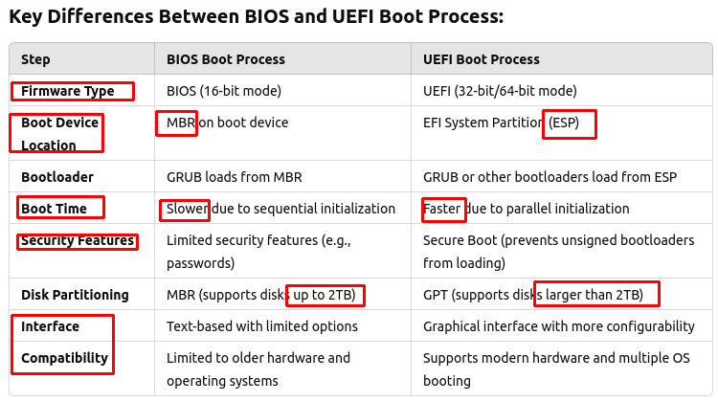
Necessary modules to read /boot/grub is already embedded in bootloader (grubx64.efi ot shimx64.efi)
================================================================

DISK CONTAINS BOOT AREA
BIOS – a disk contains MBR
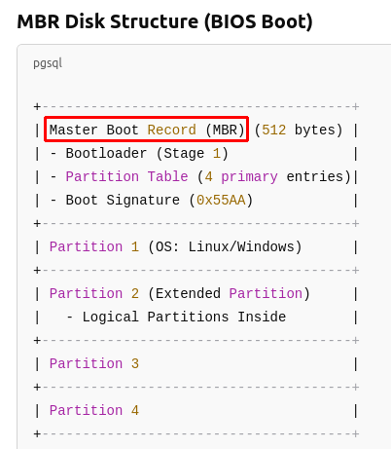

UEFI – a GPT-formatted disk contains ESP (GPT – GUID partition table)

=======================================================================
+ GPT header – the menu of the disk
+ Partition Table – list of all partition info
+ 1st partition -> EFI system partition = partition for bootloader (grubx64.efi-linux, shim.efi, bootmgfw.efi -window), UEFI driver (-FAT32)
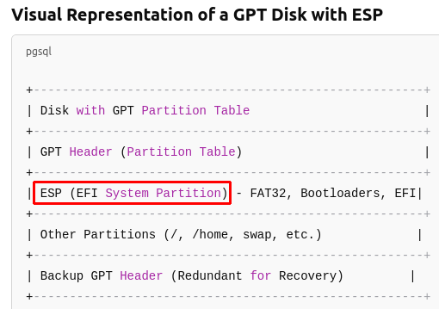
=======================================================================

BOOTING TIME
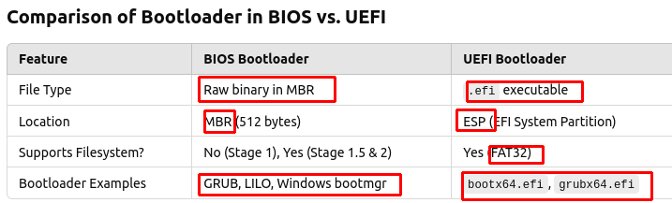
+ BIOS → load MBR → load GRUB (raw binary)
+ UEFI → read ESP → load bootloader (.efi – regular file) → faster

